Name (First Last): Christian Ruiz
Worked with: Kevin Kao, Tyler Aguilar, Danielle Rossi, Delphi Uthirakulathu
- 20 Points When a customer enters the Which Which sandwich shop, they first select the sandwich bag corresponding to the type of sandwich they want (Turkey, Ham, Pork, Beef, Veggie, etc.). They then fill out the list of ingredients they want (marked on the bag) and give the sandwich bag to Andres, who works at the cash register. It takes a customer 90 seconds to finish all the above steps after they arrive at the shop.
Andres checks in the order and asks the customer what drink they would like, which takes 15 seconds; accepts the customer’s payment, which takes 1 minute; and fills up the drink at the soda fountain for the customer, which takes 30 seconds. Then Andres puts the sandwich bag on the “order rack” above the counter, which takes 15 seconds.
The order on the sandwich bag is then read by Britt who picks the bread, adds the cheese and meat and puts the sandwich into the toaster oven. Altogether it takes Britt 90 seconds to finish this step. The sandwich stays in the oven for 1 minute. The oven is small and can hold only one sandwich at a time.
Once the sandwich comes out of the oven, Britt (the same Britt as before) adds the rest of the ingredients to it (mayo, veggies, spices, etc.); then she takes the sandwich bag off the order rack, puts the sandwich in the bag and gives it to the customer. In total, it takes Britt 1 minute to finish this step.
Experience has shown that a new customer enters the Which Which every 2 minutes on average, and that customers leave the store almost immediately after they get their sandwich.
There have been some complaints about waiting times at Which Which. The goal of this problem is to see whether the current process design justifies those complaints.

- What is the process capacity, and which is the bottleneck?
[Hint: First, draw a process flow diagram. It might be worth grouping sequential activities performed by the same person/equipment to keep the diagram compact. Also, what should Britt do while a sandwich is in the oven? Second, note that the bottleneck is either Andres, Britt, or the oven. A tricky thing with figuring out what it is, is that toasting (performed by the oven) interjects the sequence of tasks performed by Britt.]

Operations Flow Chart
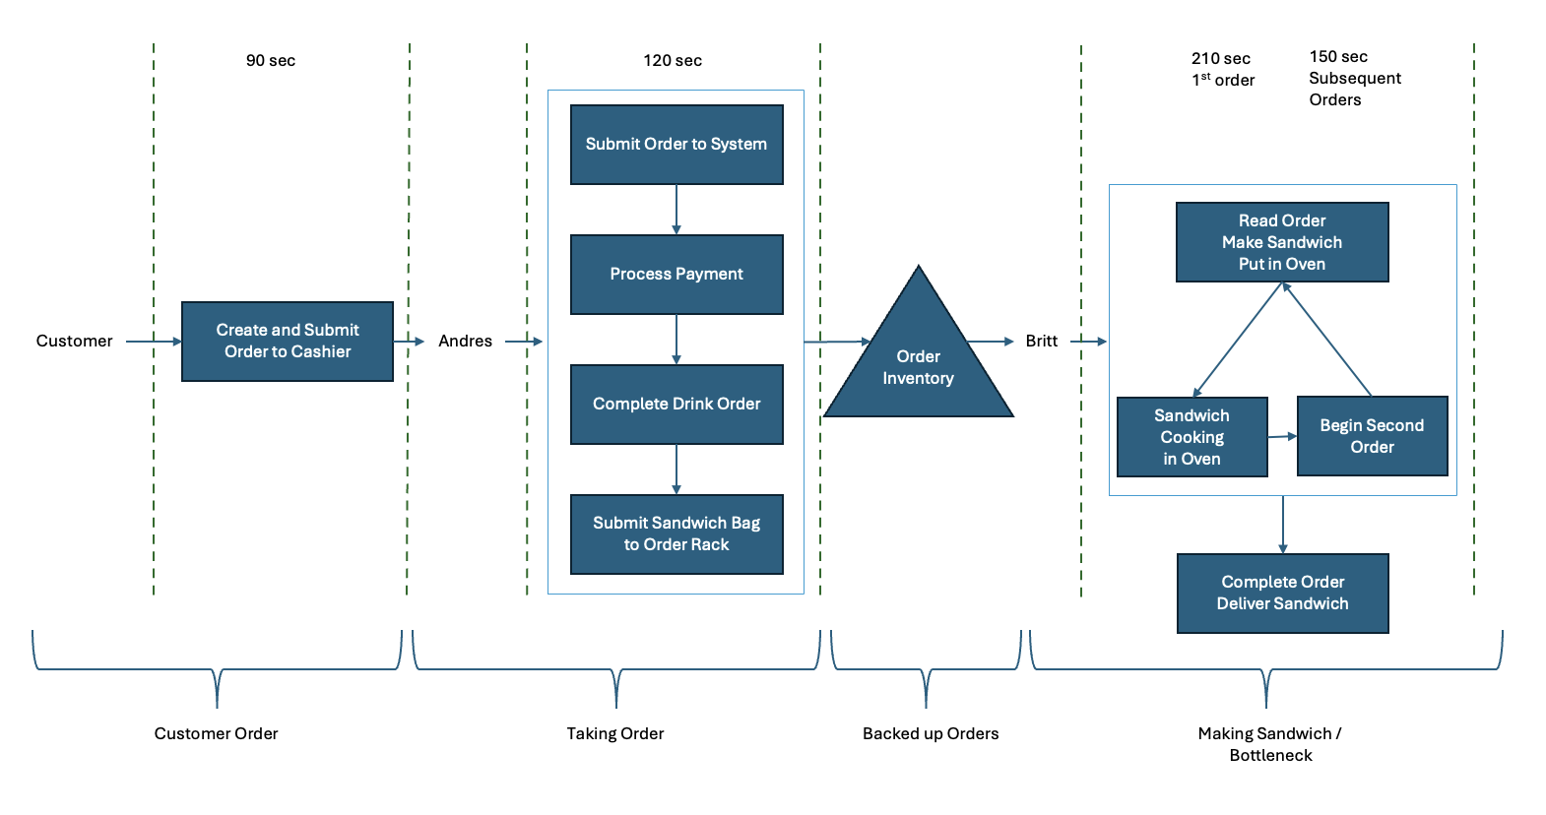

Bottleneck and Capacity Without Utilizing Toaster Oven Time
Task | Time (Seconds)
Customer: Enter Store, Create Order, Submit Order to Cashier | 90
Total Process for Customer Order | 90
Andres: Submit Order to System, Take Drink Order | 15
Andres: Process Payment | 60
Andres: Complete Drink Order | 30
Andres: Submit Sandwich bag to Order Rack | 15
Total Process Time for Andres / Taking Order | 120
Britt: Read order, Makes Sandwich, Put in Toaster Oven | 90
Oven: Cooks Sandwich, one at a time | 60
Britt: Completes sandwich order with condiments and veggies, hands order to customer | 60
Total Process Time for Britt / Making Sandwich | 210
The bottleneck for the Which Which shop is at Britt’s process, the sandwich making process, which takes 210 seconds to complete while the total time to take an order, Andres’ processing time, is only 120 seconds. Because Britt’s process is the bottleneck, we can use this time to calculate the process capacity which can be calculated as the number of sandwiches per minute.
Process Capacity = 1 sandwiches / Bottleneck Processing time
Process Capacity = 1 sandwiches / (210 sec * (1 min / 60 sec))
Process Capacity = 1 sandwiches / 3.5 min
Process Capacity = 0.286 sandwiches / min

Bottleneck and Capacity Utilizing Toaster Oven Time
Task | Sandwich One Time (Seconds) | Sandwich Two Time (Seconds)
Customer: Enter Store, Create Order, Submit Order to Cashier | 90 | 90
Total Process for Customer Order | 90 | 90
Andres: Submit Order to System, Take Drink Order | 15 | 15
Andres: Process Payment | 60 | 60
Andres: Complete Drink Order | 30 | 30
Andres: Submit Sandwich bag to Order Rack | 15 | 15
Total Process Time for Andres / Taking Order | 120 | 120
Britt: Read order, Makes Sandwich, Put in Toaster Oven | 90 | 30
Oven: Cooks Sandwich, one at a time | 60 | 60
Britt: Completes sandwich order with condiments and veggies, hands order to customer | 60 | 60
Total Process Time for Britt / Making Sandwich | 210 | 150
The bottleneck for the Which Which shop is still at Britt’s process, the sandwich making process, which takes 150 seconds to complete. If we utilize the time that Britt remains idle, waiting for the 60 seconds for the oven to complete, we can begin on sandwich two for 60 seconds. After the 60 seconds, we can complete the first sandwich and now we only have 30 seconds, rather than 90 seconds, to start the first part of the second order in preparing the sandwich. Although this reduces the time for making a sandwich, Britt’s process is still the bottleneck. We can now use this optimized time to calculate the process capacity which can be calculated as the number of sandwiches per minute.
Utilized Process Capacity = 1 sandwiches / Bottleneck Processing time
Utilized Process Capacity = 1 sandwiches / (150 sec * (1 min / 60 sec))
Utilized Process Capacity = 1 sandwiches / 2.5 min
Utilized Process Capacity = 0.400 sandwiches / min

- What are the flow rate (rate at which customers exit the sandwich shop) and cycle time (time between consecutive customers exiting the shop) of this process?
The flow rate is limited by the process capacity. Even though customers come into the Which Which shop 1 every 2 minutes, or 0.5 customers/min, our process capacity is only 0.4 sandwiches/min. Because our customers exit the shop almost immediately, if customers only order one sandwich, then the flow rate is equal to 0.4 customers/min or 0.4 customers/min * 60min/hr = 24 customers/hr.
The cycle time is the total time it takes to serve a customer at the bottleneck time. That is, for every consecutive sandwich, cycle time is equal to the process time for making a subsequent sandwich = 150 seconds or 2.5 minutes.
- Is this process capacity-constrained or demand-constrained?
This process is capacity constrained. There are more than enough customers, 0.5 customers/min but we can only product sandwiches at a rate of 0.4 sandwiches/min. Therefore, demand is high, but capacity is constrained to our bottleneck.
- Based on your analysis, are the complaints likely justified or not?
The complaints are justified. Because our process is capacity-constrained, there is a que of customers waiting as a result.

- 10 Points For each statement below, argue for or against it.
- If a process has an average flow rate of 10 units/hour, then the average total time a flow unit spends in this process is 6 minutes.
For it. If our flow rate is 10 units / 1 hour, we can calculate the time per 1 unit in the flow process by converting into minutes, that is 10 units / 1 hour * 1 hour / 60 minutes = 0.166 units / minute. But to calculate minutes per one whole unit, we can conduct simple algebra to solve,
1 unit = 0.166 units/minute * x minutes
1 unit / 0.166 units/minute = x minutes
6 minutes = x minutes
- It is possible for a process to have an average inventory of 10 units, cycle time of 12 minutes, and average flow time 3 hours.
Against it. According to littles law:
Average Inventory = Average Flow Rate * Average Flow Time
Average Inventory = 10 units,
Average Flow Rate = 1unit/12min*60min/1hr = 5 units/hr
Average Flow Time = 3 hours
This means that our average inventory is equal to the average flow rate times the average flow time, 3 hours times 5 units/hr = 15 units.

